**2 .GIT – HOL**

The objective of this lab is to understand how to prevent unnecessary files (like logs and temporary files) from being tracked by Git using a **.gitignore** file.

We follow the following steps to complete this handson.

**Steps :**

1. **Start Inside a working Repository :-**

Here, we’ll use the same repository “GitDemo” that we created in previous handson.

1. **Create Files and Folders to Ignore :-**
2. Create a .log file –

1. Create a log folder –

1. Verify it –

1. **Check Git status :-**

1. **Create a .gitignore File :-**

1. **Save and Verify :-**

1. **Add, Commit & Push the .gitignore :-**



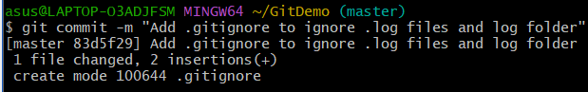

1. **Verify it in GitHub :-**

